**(Quiz Application)**

# FINAL PROJECT REPORT

CSD 3204-Web Technologies 2

**Submitted to: Mr.Rubem Linn**

**Submitted by**

**Palwinder Kaur c0737690**

**Arundeep Singh c0740006**

**Xiao Wu c0727686**

**Manish c0734815**

**Parvinder Singh c0737389**

**Tejinder Pal Singh C0739088**

**FlowChart**

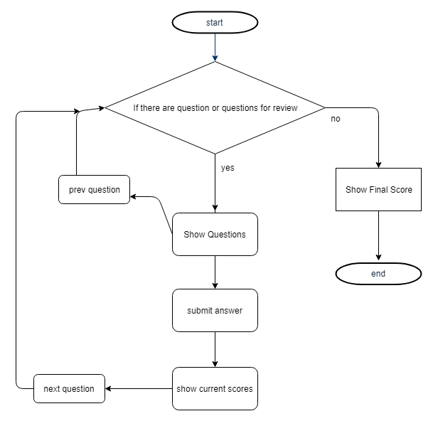

Wireframe:

